Consultation Document for Fairtrade Stakeholders  Price Review for Fairtrade Coffee |   Consultation Period: 09.02.2026 – 30.03.2026  Project Managers:  Andrea Urioste a.urioste@fairtrade.net Tatiana Casagua t.casagua@fairtrade.net
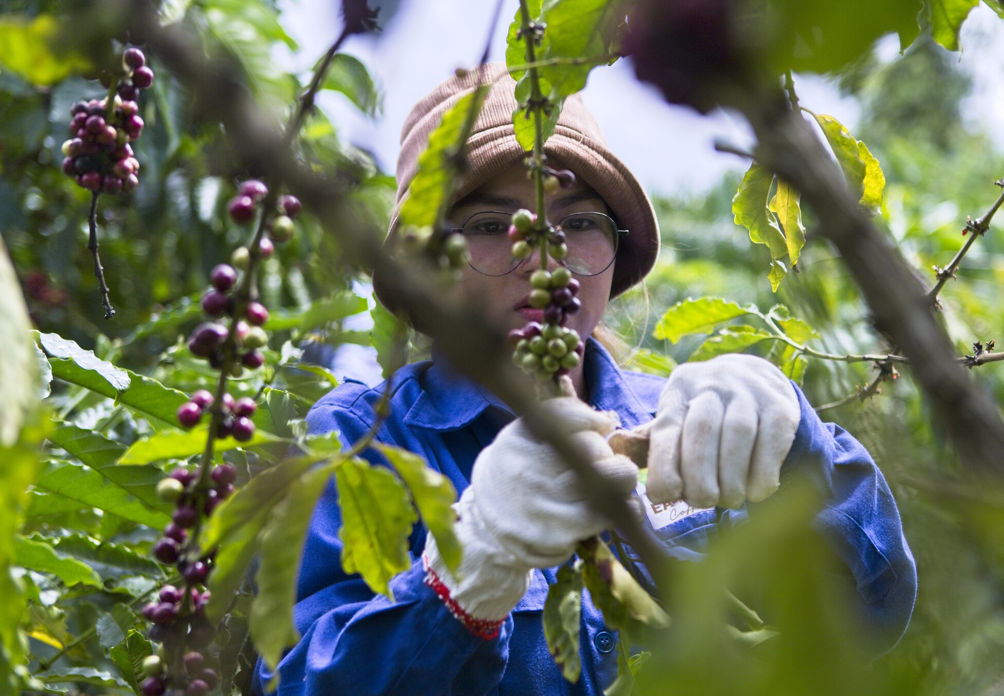

Table of Contents

Glossary 2
Your Role in Shaping Fairtrade Coffee Prices 3
How to Complete this document 3
What’s Next 4
Part 1 Introduction 5
Market Background 6
Scope of the Review 7
Key Objectives 7
Current Fairtrade Coffee Prices 7
Coffee Cost of Production 2023-2024 8
Methodology 9
Part 2 Consultation 10
1. Information about your organisation 11
2.Consultation for Fairtrade Minimum Price 14
2.1 Arabica Conventional 15
2.2 Robusta Conventional 18
3.Consultation for Organic Differential 21
4. Consultation for Fairtrade Premium 23
5.Consultation for Validity Date 25
6. Additional feedback 26

Glossary

CLAC  COSP  FAO  FTA  FMP | Network of Latin American and Caribbean Producers  Cost of Sustainable Production  Food and Agriculture Organisation  Network of Fairtrade Africa Producers  Fairtrade Minimum Price
FOB | Free on Board
FP | Fairtrade Premium
GBE | Green Bean Equivalent
HREDD | Human Rights and Environmental Due Diligence
ICO | International Coffee Organisation
NAPP | Network of Asia and Pacific Producers
NFO | National Fairtrade Organisation
SPO  SC | Small-Scale Producer Organisation  Standards Committee

Your Role in Shaping Fairtrade Coffee Prices

The Fairtrade Minimum Price (FMP), Fairtrade Organic Differential, and Fairtrade Premium (FP) for coffee are currently under review. This review forms part of the new four-year cycle for reviewing Fairtrade coffee prices, with the aim of ensuring that prices remain fit for purpose and applicable across all Fairtrade coffee-producing countries.
In line with the ISEAL Code of Good Practice—which emphasises that stakeholder feedback must be actively gathered, transparently documented, and meaningfully incorporated into decision-making—this document aims to establish formal mechanisms for collecting, analysing, and responding to stakeholder input on proposed revisions to the FMP, the FP and the Organic Differential for Fairtrade coffee. These proposals are based on data collected during the 2023–2024 coffee cost of production study.
To support the compilation and processing of stakeholder feedback, there is an online version of this questionnaire. Kindly submit your responses through this link. If you are unable to use the online version, please feel free to fill in this questionnaire in Word and send it back to standards-pricing@fairtrade.net.

Please submit your feedback—via either the online form or this Word document—by March 30, 2026.

How to Complete this document
The target groups of this consultation are:
- Fairtrade certified Coffee SPOs.
- Fairtrade licensees and retailers, as well as Fairtrade certified traders which might include roasters, green coffee exporters, importers and coffee brands.
- Producer Networks, National Fairtrade Organisations, Fairtrade International.
- Governmental bodies, NGOs, researchers and subject matter experts.
All information we receive from respondents will be treated with care and kept confidential. Results of this consultation will only be communicated in aggregated form. However, when analysing the data, we need to know which responses are from producers, traders, licensees, etc., so we kindly ask you to provide us with information about your organisation in PART 2, section 1. All feedback will be analysed and used to develop the final proposals for decision-making by Fairtrade’s Standards Committee.

What’s Next

The Fairtrade International’s Pricing Unit will prepare a report summarizing the results of the consultation which will inform the Coffee Project Team’s proposal to be presented to the Fairtrade International’s Standards Committee (SC) on the FMP, the FP and the Organic Differential. The results of the SC decision will be announced by email and on the Fairtrade International website.
If you have any questions, please contact the Project Managers:
Senior Project Manager - Andrea Urioste a.urioste@fairtrade.net
Project Manager - Tatiana Casagua t.casagua@fairtrade.net

If you are filling in the version in Word, finalize your feedback, save your document in MS Word format (do not convert to PDF) and send it back to standards-pricing@fairtrade.net

Thank you in advance for your feedback and valuable contribution to this process!

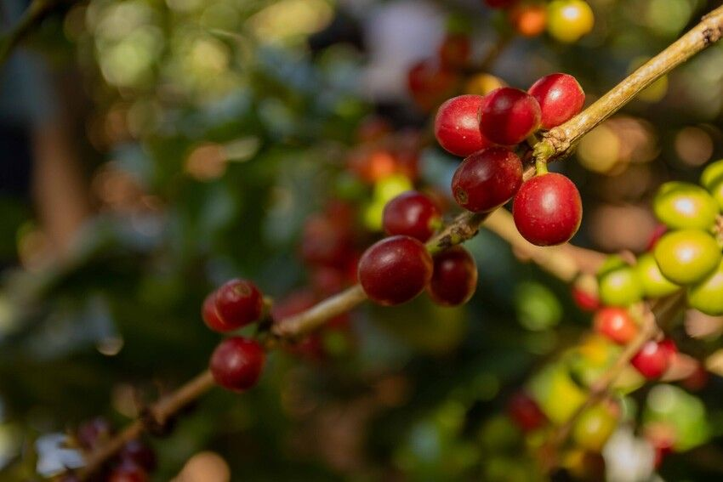

PART 1
INTRODUCTION

Market Background

Fairtrade is reviewing its prices for coffee—including the FMP, the Organic Differential and FP—to ensure they reflect today’s economic, geopolitical and environmental realities and increase the share of value across the supply chain. Fairtrade pricing mechanisms (FMP, FP and Organic differential) are designed to provide a buffer against market shocks, enabling farmers to plan, invest in sustainable practices, and contribute to the long-term stability of the Fairtrade global coffee supply chain.
About Fairtrade Arabica Coffee
Arabica coffee makes up about 92% of Fairtrade coffee. Of the total Arabica coffee, 78% is washed and 65% is certified organic. Key Fairtrade Arabica producers include Peru, Brazil, Colombia, Honduras, Mexico, and Nicaragua. Markets generating highest Fairtrade coffee sales are Germany, United Kingdom and Canada. Some of the fastest growing markets are Norway, Japan, Ireland and Belgium.
About Fairtrade Robusta Coffee
Robusta is primarily used in blends, but its Fairtrade sales remain very low compared to Fairtrade Arabica sales. Robusta accounts for 8% of Fairtrade coffee, nearly all of which is natural processed. Key Fairtrade Robusta producers include Tanzania, Vietnam, Uganda, India, and Brazil, while major markets are United Kingdom, Germany, Netherlands, Switzerland, Austria, Belgium, and France.
About Fairtrade Organic Coffee
The share of organic production grew significantly towards organic farming making up 53% of total production in 2023 in several regions including countries like Guatemala, Peru and India. While coffee production is shifting to organic, the global Fairtrade coffee sales show that organic coffee is making up close to three-quarters (70%) of total Fairtrade coffee sales. Coffee sales declined, with 2023 data indicating a decrease compared to 2022.

The Fairtrade organic differential was established to offset the additional costs of producing organic coffee and to encourage organic farming. Even in a high-price context, the organic differential is an important incentive to prevent producers from discontinuing organic production and to compensate for the additional financial burden coming with the European Union (EU) regulations.

Scope of the Review
In 2024 —drawing on lessons from the past— Fairtrade coffee stakeholders endorsed a four-year cycle for reviewing Fairtrade coffee prices. This approach aims to make cost-of-production data collection and price updates more regular and aligned with a defined timeline. The cycle begins with the collection of primary Cost-of-Sustainable-Production (COSP) data for the 2023–2024 crop year, which informs the current consultation phase and ensures consistency across the four-year cycle. Inflation and exchange rate adjustments are applied to keep the data up to date when the consultation phase begins.

Key Objectives
- Analysing production costs across coffee types collected from Fairtrade certified coffee producers and validated by Fairtrade field staff.
- Proposing price levels that support coffee production without systematic economic loss.
- Engaging stakeholders to gather feedback and refine proposed price values.
- Exploring alternative pricing models suited to varying market conditions.
- Evaluating the role of the price in supporting long-term market stability.

Current Fairtrade Coffee Prices
Between 2022 and 2023, Fairtrade International conducted the last price review for coffee, establishing the current global Fairtrade coffee prices following consultation with stakeholders.
Table 1.1 Fairtrade Coffee Pricing Table
Applicable since August 2023

Coffee Type | Processing Method | Fairtrade Minimum Price USD/lb | Organic differential USD/lb | Fairtrade Premium USD/lb
Arabica | Washed | 1.80 | 0.40 | 0.20
Arabica | Natural | 1.75 | 0.40 | 0.20
Robusta | Washed | 1.25 | 0.40 | 0.20
Robusta | Natural | 1.20 | 0.40 | 0.20

According to requirement 4.1.1 of the Fairtrade Coffee Standard for small-scale producers, when market prices exceed the FMP, producer organisations, payers, and conveyors must agree on coffee prices using Fairtrade’s reference for market pricing.

Coffee Cost of Production 2023-2024
Table 1.2 shows the sample used to collect data from the crop period 2023-2024 from Fairtrade certified coffee small-scale producers’ organisations (SPOs).
Table 1.2. Sample used for data collection
 | Country | SPO | Farmers | Coffee specie | Conventional/ Organic
1 | Rwanda | 3 | 17 | Arabica | Organic/Conventional
2 | Uganda | 3 | 42 | Robusta/Arabica | Organic
3 | Ethiopia | 3 | 23 | Arabica | Organic
4 | Kenya | 3 | 38 | Arabica | Conventional
5 | Brazil | 3 | 15 | Robusta/Arabica | Conventional
6 | Colombia | 8 | 15 | Arabica | Organic/Conventional
7 | Honduras | 7 | 15 | Arabica | Organic
8 | Mexico | 4 | 15 | Arabica | Organic
9 | Nicaragua | 3 | 15 | Arabica | Organic/Conventional
10 | Peru | 10 | 15 | Arabica | Organic
11 | Indonesia | 4 | 15 | Arabica | Organic
12 | Vietnam | 3 | n/a* | Robusta | Conventional
13 | India | 3 | n/a* | Robusta | Organic
Total |  | 57 | 225
Note: in the case of Vietnam and India online Focus Groups discussions were held only.

The collected data covered costs at three levels: farmgate, Ex Works, and Free on Board (FOB). It was gathered using a newly developed and field-tested template designed to better capture information from organic producers and those implementing biodiversity-friendly practices.
The data for India and Vietnam was sourced from updates made during the 2022 coffee price review, which was later validated through online focus group sessions led by producer organisations.
After cleaning and validating the data in collaboration with Producer Networks and SPO representatives, the data was compiled and processed using updated exchange rates and inflation figures as of September 2025. Conversion factors were applied to calculate FOB values in Green Bean Equivalent (GBE).
Following the existing Fairtrade coffee price setting, the analysis segmented the sample to differentiate prices by coffee species (Arabica vs. Robusta), production method (organic vs. conventional), and processing type (washed vs. natural). Both average and median prices were considered for consultation. The choice to use these measures was based on their ability to keep the analysis simple and transparent. Key findings from the COSP Study are compiled which is managed with confidentiality, as it contains business sensitive data from coffee producers.

Methodology
The Coffee Cost of Sustainable Production (COSP) represents average values across countries and coffee types, and it is calculated at a global level. This means it is intended to reflect general production costs worldwide, rather than specific figures for individual origins. The following considerations help to define what constitutes a FOB global price, expressed in US dollars and in GBE:
- It may be higher or lower than production costs in specific origins.
- It accounts for diverse farming contexts, including productivity levels, farm size, sustainable practices, and transaction costs such as transport and export fees.
- Country FOB values may be influenced by recent inflation and currency fluctuations when converting local prices to US dollars, making it harder to compare between countries or with the baseline.

In the following section, you will be asked to provide information about your organisation, and your role in the supply chain. This is particularly important as it helps us understand the perspective of the answers provided. We kindly ask you to complete the questionnaire before proceeding with the consultation itself. Depending on thoroughness of your responses, the survey you are about to answer will take approximately 20 minutes to complete.

Thank you in advance for your cooperation

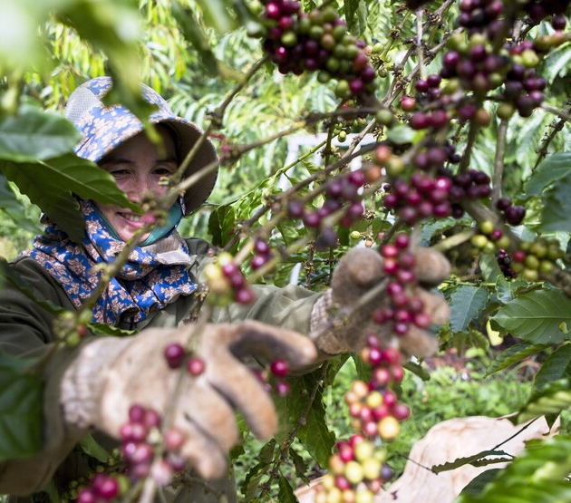

PART 2
CONSULTATION

1. Information about your organisation

The consultation is aimed at organisations (e.g. SPO, Traders). If you are a Small-Scale Producer Organisation (SPO) we encourage you to involve your members. Please provide the information below. Your responses will be used solely for the analysis of the consultation.
1.1 Organisation Information
Please, provide basic information about your organisation.
Name of your organisation
Grade of the organisation (1st, 2nd 3rd.) (if applies)
Name of contact person
Email address
Phone number
Country
Region
FLO ID (if applies)

1.2 Supply Chain Primary Role
1.2.1 Please select all applicable boxes corresponding to the activities your organisation performs in the supply chain bearing in mind that multiple answers are allowed:

Producer Organisation
Processor
Exporter
Importer
Roaster/Manufacturer
Brand
Retailer
Licensee

1.2.2 If you are not responding on behalf of any of the organisations in the coffee supply chain listed in 1.2.1, please indicate the organisation you represent in this consultation by selecting it from the list below:

NFO (National Fairtrade Organisation)
Fairtrade Producer Network
NGO (Non-Governmental Organisation)
Other, please specify:

1.3 Species of Coffee
Provide information only for coffee produced, sold, or purchased on Fairtrade terms.
1.3.1 Indicate which coffee species are part of your organisation’s Fairtrade operations.
Arabica
Robusta
Both Robusta and Arabica

1.3.2 Provide the approximate proportion of Arabica and/or Robusta coffee that your organisation sold or bought on Fairtrade terms in the last two years, expressed as percentages.
Arabica: %
Robusta: %

1.3.3 Use the checkboxes in the table below to specify which processing methods (washed or natural) and production types (only conventional, only organic, or both) of Arabica coffee your organisation sells or buys.
Arabica
Production/Processing Type | Only Conventional | Only Organic | Both Organic/ Conventional
Washed
Natural

1.3.4 Based on your answer in 1.3.3 for Arabica, what was the approximated proportion of coffee you sold/bought on Fairtrade terms in the last two years? Please provide an indicative percentage.
Processing Type | Organic (%) | Conventional (%)
Washed
Natural

1.3.5 Use the checkboxes in the table below to specify which processing methods (washed or natural) and production types (only conventional, only organic, or both) of Robusta coffee your organisation sells or buys.
Robusta
Production/Processing Type | Only Conventional | Only Organic | Both Organic/ Conventional
Washed
Natural

1.3.6 Based on your answer in 1.3.5, what was the approximated proportion of Robusta coffee you sold/bought in Fairtrade terms in the last two years? Please provide an indicative percentage.
Processing Type | Organic (%) | Conventional (%)
Washed
Natural

1.4 Fairtrade Coffee Sourcing Regions
For coffee buyers. Please indicate the regions from which you source Fairtrade coffee. (Multiple responses allowed)

Latin American and the Caribbean
Africa
Asia
Other, please specify:

2.Consultation for Fairtrade Minimum Price
Definition
The Fairtrade Minimum Price is based on the principle of covering average costs of sustainable production of the products, while enabling the average producer to produce in an economic and financial sustainable way without systematic economic losses. This requires not only covering the average costs of production but also considering market acceptance to ensure that the FMP does not compromise the ability to sell the product
Methodology
Where applicable, price proposals include both global average and median values from the COSP reported from certified Fairtrade producers.
- Average represents the arithmetic mean, calculated by dividing the sum of all country cost of production in GBE and coffee types at FOB level by the number of entries. It reflects equal sharing and is sensitive to countries with exceptionally high or low production costs.
- Median represents the midpoint of the dataset, dividing it into two equal halves. It offers a more balanced view of typical production costs, especially in the presence of extreme values. Unlike the average, the median is not influenced by very high or very low values. It is simply the number that sits in the middle when all the values are put in order. For the current analysis, some median values were not included due to limitation in the sample.

Table 2.1 Proposal for Fairtrade Minimum Price
FOB level of GBE
Expressed in USD/lb.
Coffee Species | Production System | Processing Method | Current | Proposal for consultation
 |  |  |  | Option 1  No change | Option 2 Median | Option 3  Average
Arabica | Conventional | Washed | 1.80 | 1.80 | 2.00 | 2.25
Arabica | Conventional | Natural | 1.75 | 1.75 | 1.95 | 2.20
 |  |  |  | Option 1  No change | Option 2  Average
Robusta | Conventional | Washed | 1.25 | 1.25 | 1.35
Robusta | Conventional | Natural | 1.20 | 1.20 | 1.30
Note: Values were rounded to make the data easier to read and to avoid showing unnecessary detail

2.1 Arabica Conventional
Arabica Conventional Washed
Proposal. Arabica Conventional Washed coffee is proposed using both average ($2.25 USD/lb) and median ($2.00 USD/lb) values.
Rationale. Based on the COSP Study 2023–2024, the cost of production for Arabica Conventional Washed showed a 24% increase on the average and a 12% increase based on the median from the current FMP of $1.80 USD/lb.
The Arabica Conventional Washed sample includes Fairtrade coffee data from Colombia, Kenya, Nicaragua and Rwanda. For the average option, all countries in the sample are considered, as the average calculation (option 3 – average from table 2.1) reflects an equitable distribution and is sensitive to countries with significantly high (e.g. Nicaragua), or low (e.g. Kenya) production costs.
In the case of the median option consulted (option 2 – median from table 2.1), only countries close to the centre are considered. In the presence of extreme values, the median is not influenced by high values such as Nicaragua, or low values such as Kenya.
Arabica Conventional Natural
Proposal. Minimum price proposals for Arabica Conventional Natural are presented using both average ($2.20 USD/lb) and median ($1.95 USD/lb) values.
Rationale. The pricing approach follows the same approach set in the coffee price review in 2011 and 2022, maintaining a fixed differential of $0.05 USD/lb (5 cents) between Natural and Washed coffee.

The cost of production study does not provide sufficient evidence to set prices exclusively for washed or natural coffees. Therefore, following the precedent from 2011 and the 2022–2023 coffee price consultation—where the 5-cent differential was positively received—the same approach was maintained as was perceived by the Project Team as simple and predictable for contract negotiations. As a result, once Arabica washed prices are selected, natural prices are automatically determined based on the 5-cent differential.

The Project Team considered the weighted average calculation, but ultimately not included it. The weighted average, based on each country’s share of Fairtrade sales within the sample, implies that countries with significantly high production costs and, at the same time, significant Fairtrade sales shares exert upward pressure on the overall average. The Project Team therefore reached a consensus to advise against using a value weighted by Fairtrade sales, as it would not fairly represent all origins and could negatively affect regional balance.

We consider also applying an inflation adjustment to the current price of washed Arabica. However, this approach would reflect changes based on final market prices rather than on actual cost of production datasets.
Question for Arabica Conventional Washed & Natural
The current FMP for Arabica Conventional Washed coffee is 1.80 USD/lb and for Arabica Conventional Natural coffee is 1.75 USD/lb.

2.1.1 Which FMP values (in USD/lb GBE) do you consider the most appropriate for each of Arabica Conventional Washed and Natural coffees? (Please select only one option)

Coffee Species | Production System | Processing Method | Option 1  No change | Option 2 | Option 3
Arabica | Conventional | Washed | 1.80 USD/lb | 2.00 USD/lb | 2.25 USD/lb
Arabica | Conventional | Natural | 1.75 USD/lb | 1.95 USD/lb | 2.20 USD/lb
Rationale for agreement |  |  | I consider a no change is the most reasonable option. | I consider option 2 to be reasonable for both the market and producers, based on the median cost of production from Fairtrade producers (2023-2024 COSP Study) | I consider Option 3 to be reasonable for both the market and producers based on the average cost of production (2023-2024 COSP Study)

2.1.2 In case you did not choose Option 2 or Option 3, which of the following rationales better justifies your decision?

Rationale A | Rationale B
I consider option 2 and 3 unreasonable as it is too low for producers | I consider option 2 and 3 unreasonable as it is too high

2.1.3 In case you do not agree with the 5-cents differential between washed and natural, which rationale better reflects your view on this proposed differential?
Rationale A | Rationale B
I believe the differential should be higher, as the 5-cent difference falls too short and does not reflect the full, real cost of production difference. | I believe the differential should be lower, as the 5-cent difference is too high and does not reflect the real cost of production difference.

2.2 Robusta Conventional
Robusta Conventional Natural

Proposal. Minimum Price proposal for Robusta Conventional Natural coffee is presented using only the average price of $1.30 USD/lb, as shown in table 2.1. This is because the sample size was small to propose a median value.

Rationale. The COSP Study 2023–2024 found that the cost of production for Robusta Conventional Natural increased by 8.3% on the average, compared to the current FMP of $1.20 USD/lb. The sample for Robusta Conventional Natural includes Brazil and Vietnam origins.

Robusta Conventional Washed
Proposal. The FMP proposal for Robusta Conventional Washed is $1.35 USD/lb.
The consultation also includes a ‘no change’ option for all coffee processing methods and species (Arabica and Robusta), allowing stakeholders to select the current price without any change.

Rationale. The COSP study does not provide sufficient evidence to set prices exclusively for washed or natural coffees. Therefore, following the precedent from 2011 and the 2022–2023 coffee price consultation—where the 5-cent differential was positively received—the same approach was maintained as was perceived by the Project Team as simple and predictable for contract negotiations. As a result, once Robusta Natural prices are selected, washed prices are automatically determined based on the 5-cent differential. Lastly, consistent with the approach taken for Arabica, a weighted average was considered for Robusta, but it was also excluded.

Question for Robusta Conventional Natural & Washed

The current FMP for Robusta Conventional Washed coffee is 1.25 USD/lb and for Robusta Conventional Natural coffee is 1.20 USD/lb.

2.2.1 Which FMP values (in USD/lb GBE) do you consider the most appropriate for each of Robusta Conventional Washed and Natural coffees? (Please select only one option)

Coffee Species | Production System | Processing Method | Option 1  No change | Option 2
Robusta | Conventional | Washed | 1.25 USD/lb | 1.35 USD/lb
Robusta | Conventional | Natural | 1.20 USD/lb | 1.30 USD/lb
Rationale for agreement |  |  | I consider a no change is the most reasonable option. | I consider option 2 to be reasonable for both the market and producers, based on the average cost of production from Fairtrade producers (2023-2024 COSP Study)

2.2.2 In case you did not choose Option 2, which of the following rationales better justifies your decision?

Rationale A | Rationale B
I consider option 2 unreasonable as it is too low for producers | I consider option 2 unreasonable as it is too high

2.2.3 In case you do not agree with the 5-cents differential between washed and natural, which rationale better reflects your view on this proposed differential?

Rationale A | Rationale B
I believe the differential should be higher, as the 5-cent difference falls too short and does not reflect the full, real cost of production difference. | I believe the differential should be lower, as the 5-cent difference is too high and does not reflect the real cost of production difference.

3.Consultation for Organic Differential

Rationale. The Project Team analysed the cost gap between the cost of production in organic versus conventional systems. The sample for organic production includes India and Uganda for Robusta Natural. Colombia, Ethiopia, Honduras, Indonesia, Mexico, Nicaragua, Peru, Rwanda, Uganda for organic Arabica Washed, and Ethiopia for Arabica Natural.

The data collected representing the cost of production for the crop period 2023-2024 showed in average and median levels higher costs in crop management at the farmer level. Calculations showed several potential differential values using median and average cost estimates. These values were slightly below—but closely aligned— with the current differential of $0.40 USD/lb (40 cents).

Proposal. Based on the COSP study findings presented above and the current market context, characterized by high international coffee prices and volatility, the Fairtrade Project Team members advised to consult maintaining the existing $0.40 USD/lb (40 cents) differential to ensure stability, avoid any disruption in existing buyer commitments, and provide farmers with a fixed, known differential that is already established and understood in the market.

Question for Organic Differential
The current Fairtrade Organic Differential (the premium paid for organic certification) for all types of Fairtrade coffee is set at $0.40 USD/lb (40 cents). The Project Team advice maintaining this $0.40 USD/lb Organic Differential for all Fairtrade coffee varieties.
3.1 What is your level of agreement with maintaining the $0.40 USD/lb Organic Differential?
Level of agreement | Meaning | Select
Strongly agree | I am completely satisfied with the organic differential set at $0.40 USD/lb (40 cents) and I consider it very appropriate
Agree | I find the organic differential set at $0.40 USD/lb to be reasonable and acceptable
Neither agree nor disagree | I find the current organic differential acceptable, but have observations or minor concerns about its suitability
Disagree  (a little low) | I think the organic differential set at $0.40 USD/lb is not acceptable as I consider it a little low.
Disagree  (a little high) | I think the organic differential set at $0.40 USD/lb is not acceptable as I consider it a little high.
Strongly disagree  (too low) | I think the organic differential set at $0.40 USD/lb is inappropriate as I consider it too low
Strongly disagree  (too high) | I think the organic differential set at $0.40 USD/lb is inappropriate as I consider it too high.

4. Consultation for Fairtrade Premium
The Fairtrade Premium (FP) is designed to give farmers additional resources to invest in improving their social, economic, and environmental conditions and it is essential for producer organisations to finance activities to reduce and mitigates risks. Decisions on how to use this income are made democratically by members of the producer organisation. Currently, the FP for coffee is set at $0.20 USD/lb, which accounts for approximately 11% of the current FMP for Arabica Conventional Washed.
Fairtrade acknowledges growing expectations to address human rights and environmental risks throughout the supply chain. However, in the current context of elevated market prices, it’s important for stakeholders to recognize that the FP is an added benefit—supplementing an already high base price.
Rationale
The Fairtrade Premium has remained unchanged since 2011. During the 2022/23 consultation, most stakeholders favoured keeping the existing FP values. For the current consultation, two methodologies were proposed:
The first methodology calculates a proportional increase in the Premium by applying the percentage increase in FOB costs for conventional Arabica (a 24% increase based on the average, and a 12% increase based on the median) and Conventional Robusta (a 8% increase based on the average).
The second methodology adjusts the original Fairtrade Premium using cumulative inflation from March 2011 to September 2025 (45%). This approach ensures the Premium retains its original purchasing power from the last time it was set at its current value.
Proposal
The proportional increase in the Fairtrade Premium based on the percentage rise in FOB costs for conventional Arabica and Robusta coffees shows an average value of $0.25 USD/lb for Fairtrade Premium.
Considering the cumulative inflation since 2011 at a rate of 45%, results in an average value of $0.30 USD/lb for the Fairtrade Premium. The Project Team decided not to use this value in the consultation because a 45% increase would be disproportionately high compared with the other proposed Fairtrade coffee price proposals. Given the 2022 decision not to modify the Premium due to potential market reactions, and considering that a 45% increase would significantly exceed the percentage changes indicated by the current cost study for the Arabica and Robusta prices, the Project Team recommends proceeding with symmetrical percentage changes proposed in the first methodology.

Question for Fairtrade Premium
The current Fairtrade Premium for coffee is $0.20 USD/lb. It has been proposed that the price be increased to $0.25 USD/lb.
4.1 Which of the following proposed Fairtrade Premium prices do you consider the most appropriate? (Please just select one option)
Option | Value | Select
Option 1: No Change | $0.20 USD/lb.
Option 2 | $0.25 USD/lb.

4.2 How satisfied are you with the newly proposed value of $0.25 USD/lb? Please indicate your level of satisfaction by selecting the most appropriate option below

Level of agreement |  | Select
Agree | This value is regarded as reasonable, as it is supported by the outcome of the 2023–2024 COSP study and by market acceptance
Disagree (too low) | I consider that $0.25 USD/lb. is too low
Disagree (too high) | I consider that $0.25 USD/lb. is too high

5.Consultation for Validity Date
Rationale
Coffee contracts vary widely by region. In Mexico and Central America, contracts are typically signed between August and September. In Asia, negotiations usually begin in July, with contracts signed between October and November. In South America, contracts are often finalized later in the year—around March or April. For African countries, both three- and six-month transition periods are commonly applied, particularly in markets such as Uganda and Ethiopia.
Please note that contracts agreed for Fairtrade coffee before the date of validity will refer to the current Fairtrade prices. For contracts which are signed after the validity date, the new Fairtrade prices for coffee should be respected. The decision on Fairtrade prices is expected to be in July 2026. The proposal below follows the expected date of announcement.
Proposal
A 3‑month transition is short enough to show responsiveness and align with Central American cycles, while a 6‑month transition accommodates Asian and South American markets. Together, they balance feasibility, fairness, and market stability—making them the most appropriate options. A transition period of three, six and nine months are proposed below. This is to allow commercial stakeholders to prepare for any changes to Fairtrade Coffee pricing.
Question for Validity Date
5.1 Which transition period should apply for price implementation following the announcement of the FMP and FP?

Option | Select
3 months
6 months
9 months

6. Additional feedback

This section is designed to gather your feedback on additional topics that you would like to share. This will help the Project Team to better understand the outcomes of this consultation and inform future reviews. If you have feedback on any previous question, please indicate the question number and then provide your feedback. Responses should be concise and limited to approximately 600 characters.
Please explain your rationale here:

Thank you!! You have reached the end of the consultation

Fairtrade International conducted a coffee cost of production study based on data from the 2023–2024 crop cycle.
See Fairtrade Standard for Coffee to review how coffee price and premium is implemented. https://www.fairtrade.net
Fairtrade Coffee Standard Requirement 4.1.5 sets a Fairtrade Premium earmark in at least 5 cents per pound of coffee sold to improve productivity, quality and/or enhancing sustainable agricultural practices.

